The Legend of Zelda: Ocarina of Time (1998, Nintendo 64), Nintendo. GAMEPLAY

1. Composition
Tangible space | The projected world, occupying the entire screen surface.
Intangible space | Interface icons overlaid across the edges of the screen.
Negative Space | A static backdrop image of the sky and mountain range
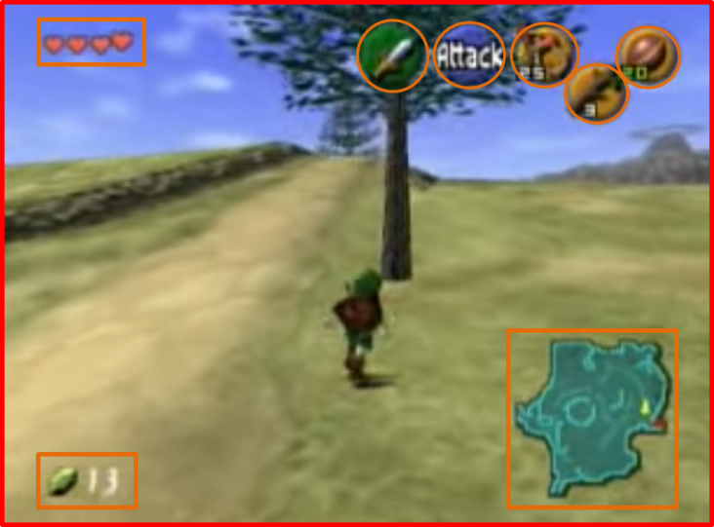
External | Zero Ergodic*
2. Ocularization

3. Framing mechanisms | Anchor : Subjective | Mobility : Connected

4. Plane Analysis
 | Agents | In-game | Off-game
Graphical materials | Real-time polygons | Real-time polygons | Raster backdrops
Projection method | Linear | Linear | Linear
Angle of projection | Various | Overview | Horizontal

Notes :
An early example of the “3D third-person” view that can be found in many games nowadays. At the time, free-range camera controls hadn’t been fully standardized yet. If the player wants to see what’s on his left, for instance, he needs to move Link to the left to have the camera pan automatically following the anchor and according to its connected mobility. This means the camera provides ocularization that lies somewhere in-between the internal secondary and zero ergodic categories: it is connected to Link’s perception of the world, but less so than the usual internal secondary viewpoint; yet it is not a case of full camera control either, as in Wind Waker.

The game shifts ocularization strategies, with the camera following along as the player-character moves in the overworld and dungeons, sometimes being immobile on certain spots (such as atop the fountain in the village), and shifting into internal secondary ocularization when the player Z-targets an enemy.

